SNOWMAN ORNAMENT BY Eric Owens
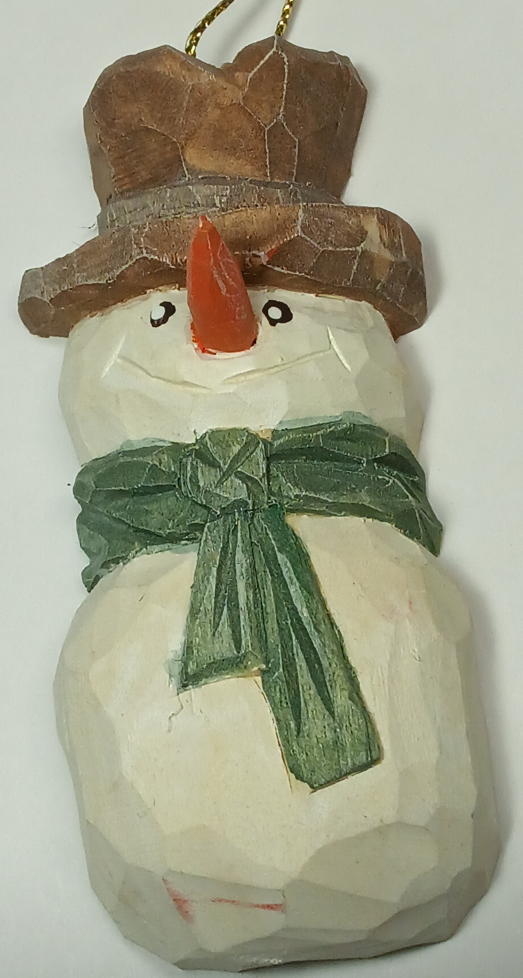
Wood – Use a 1” thick by 2 inch wide by 4 inch tall piece of basswood, cut to pattern.
Steps:
- Draw the hat, scarf and middle line.
- Start by shaping the brim of the hat to a semi-circle.
- Round the crown of the hat and carve in the hat band.
- Thin the hat brim and give the shape some dimensions.
- Round body by taking off the sharp corners and edges.
- Draw in the scarf and carve it with the v-tool.
- Draw and carve in any details you desire, such as arms, scarf knot, etc.
- Drill hole for carrot nose.
- Carve the carrot nose and insert it into the hole you drilled.
- Round head and add finishing details to the body.
- Paint with watered down craft acrylic paints.
- Seal or stain the carving to preserve it.
- Paint the eyes and mouth to look like lumps of coal.
- Add highlight details to the eyes.
- Put in a screw eye to the top and add a string to hang it on your tree.
- Sign and date your carving. Enjoy!
Supplies used in this class
Description | Item #
Flexcut KN13 Medium knife | 814267
Flexcut FR409 #11” x 3/16” U-gouge | 128320
Flexcut FR307 70 degree x 1/4” V-tool | 128309
Flexcut FR400 #3 x 5/8” Fishtail gouge | (unknown)
Safety Glove to fit non-dominant hand (XS/S/M/L/XL) | (unknown)

